* ©­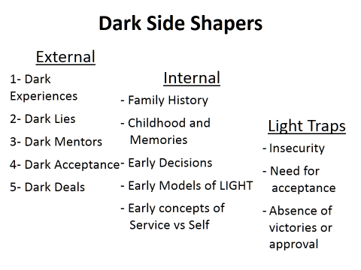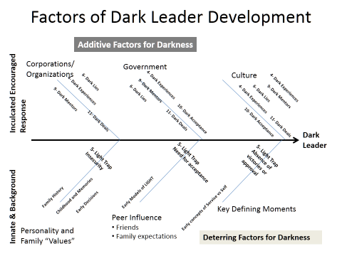

*Leader quality is like a fine cut diamond.*

*Higher the quality, greater the LIGHT.*

*How do you shine through?*



**The MODEL**

***Five Questions compose a virtual "filter" to look at a leader.***

***Ask:***

***1. Who the leader is?***

***2. What the leader does?***

***3. How the leader relates?***

***4. What drives the leader?***

*5. What does the leader leave behind?*





LIGHT© Leadership Institute



MISSION

Our mission is to promote Leader excellence and save Leaders from derailment by providing a model to reflect the leader in the mirror as well as evaluate others,

VISION

LIGHT Leadership Institute promotes Leader excellence by encouraging servant leaders who accomplish the mission and maintain a sense of self.

.

PURPOSE

The LIGHT Leadership Institute is dedicated to preventing leaders from drifting to the dark side - or to snatch them out of the fire if they do something that causes them to "derail."

Type your call-out text

LIGHT© in Action

Exposing the Darkside of Leadership

The Darkside Path – Questions

* What role does the environment or situation or “conditions” play?
* Is Dark Leadership INNATE or INCULCATED?
* Did the “Devil really make you do it?”
* What are the LIGHT blockers?
* How can one avoid falling into the grip of the DARK side?

**Factors of Dark Leader Development**

**Dark**

**Leader**

**Additive Factors for Darkness**

**Deterring Factors for Darkness**

Government

Peer Influence

•

Friends

•

Family expectations

Culture

Corporations/

Organizations

**Innate & Background**

**Inculcated Encouraged**

**Response**

Key Defining Moments

Personality and

Family “Values”

**Are YOU READY to Lead?**

Contact us for lessons on applying the model.

Personal coaching and enlightened advice.

Available for group presentations.

[**www.lightleadershipinstitute.org**](http://www.lightleadershipinstitute.org)

5205 Shenstone Circle

Virginia Beach VA 23455

757-839-8391

David K. Brown, Captain, USN (Ret), PhD

[**DKBrown37**@lightleadershipinstitute.org](mailto:DKBrown37@lightleadershipinstitute.org)

Get READY for the LIGHT

**R**ead- learn what good and bad and light and dark leadership mean. Reflect using the LIGHT.

**E**xplore and expand your leadership comfort zone.

**A**spire for the leadership challenge; accept and acknowledge the reality of dark tendencies.

**D**iscover and appreciate diversity. Dare to dream.

**Y**ou. Authentic, Transparent, and Focused on mission.

LIGHT© Leadership Institute

Exposing the DARK side of LEADERSHIP